Ex.No:7
DATA VISUALIZATION USING TABULEAU
Date:

AIM:
To import, transform, analyze, and visualize data using Tabuleau Desktop and create interactive dashboards and reports for decision-making.

ALGORITHM:

OUTPUT:
Importing Data into Tabulaeu:

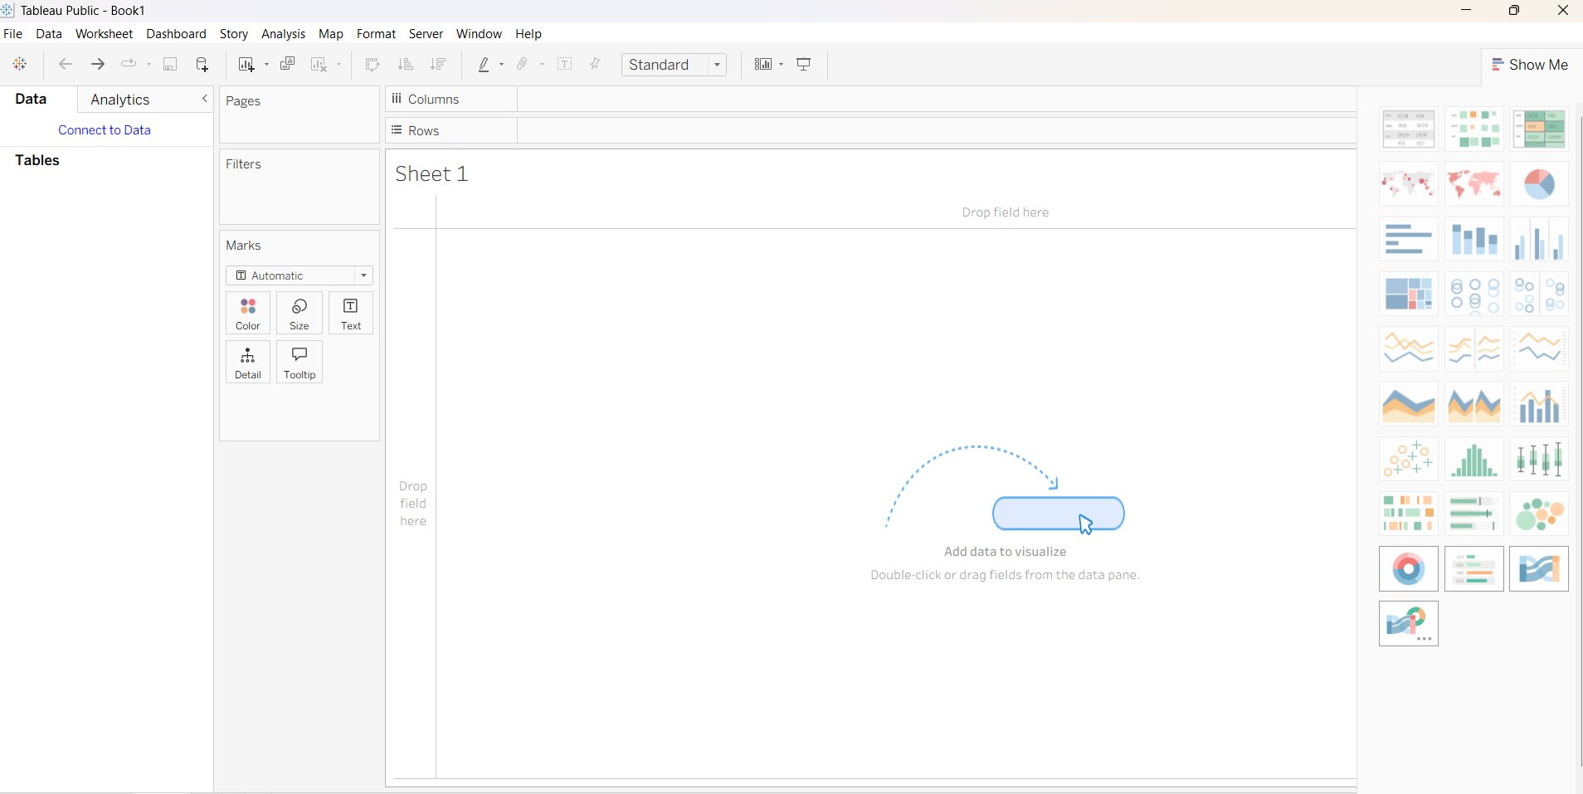
Imported dataset displayed in Data View:

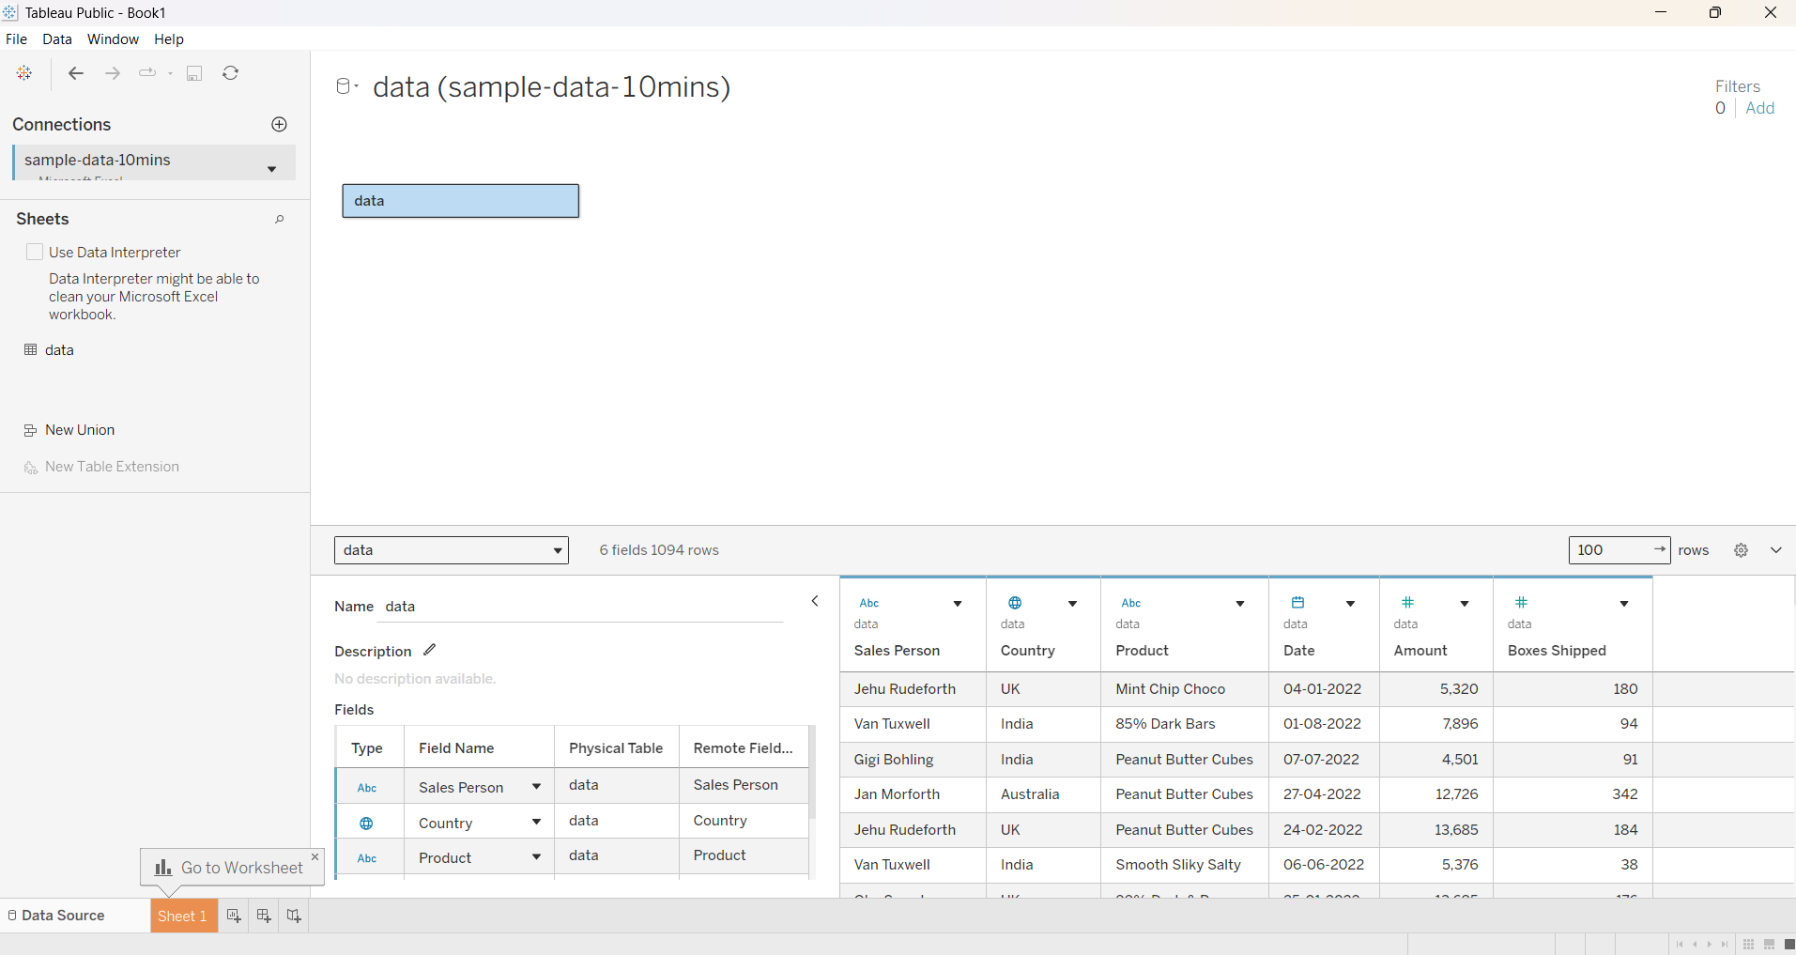
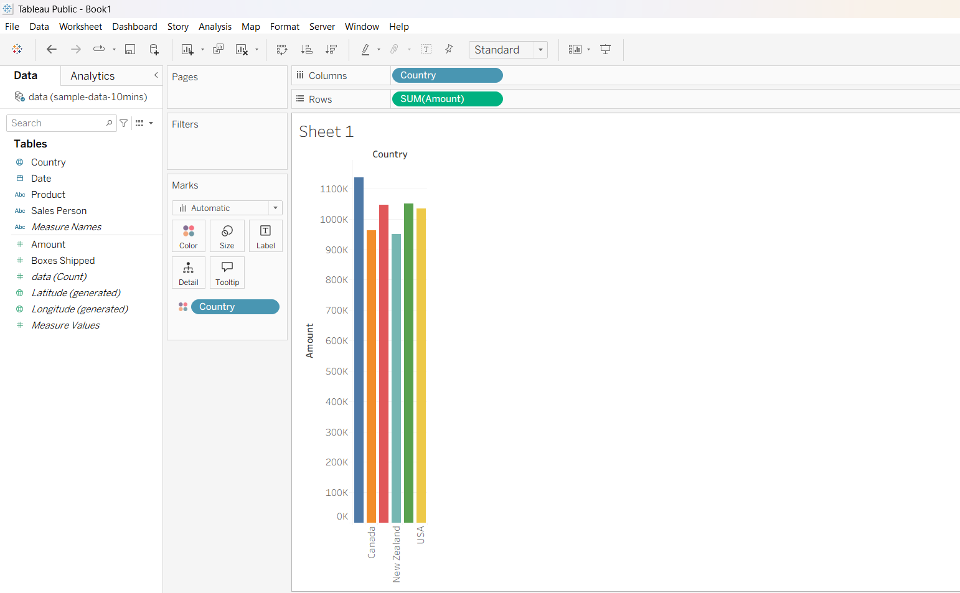

Making a Top 10 sales:

1).Apply filters:

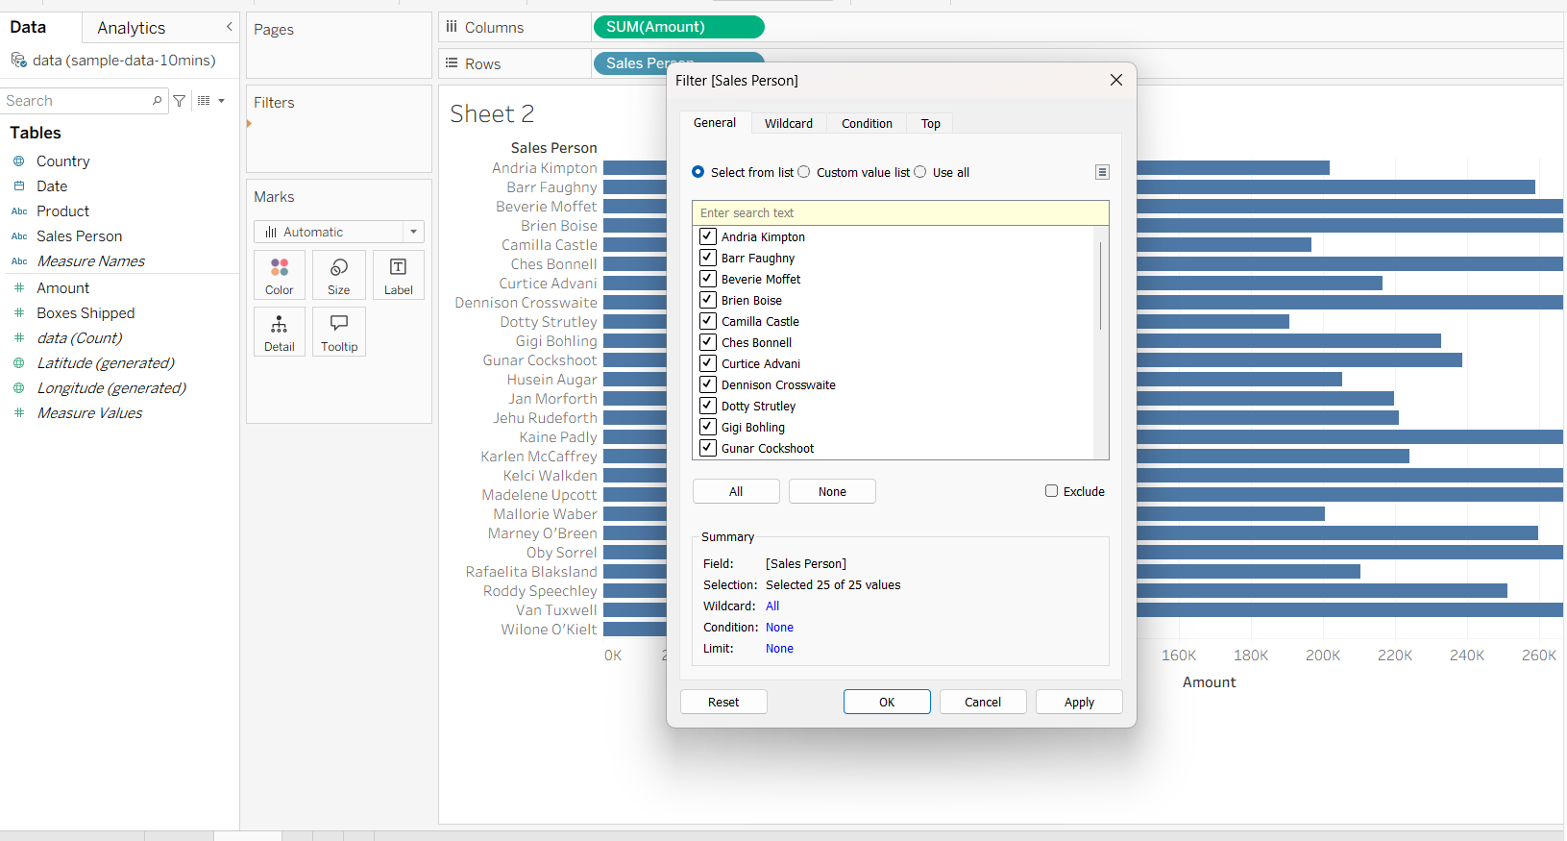

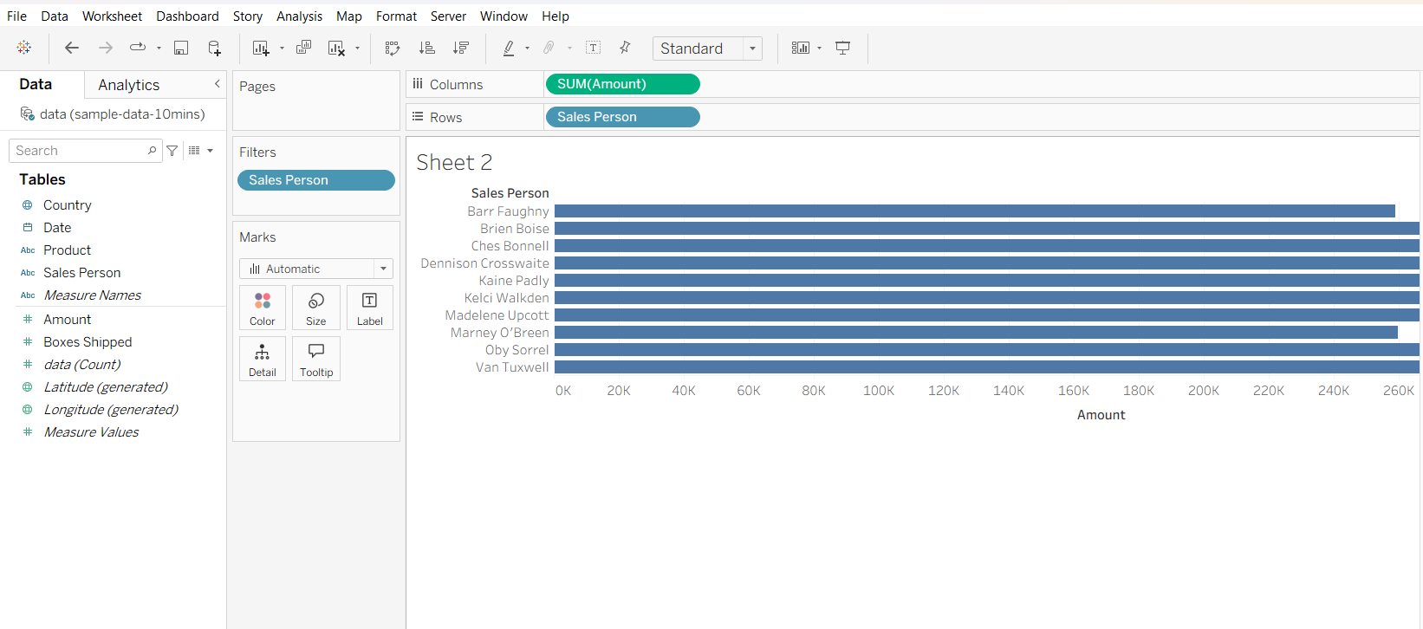

2). Make DashBoard in Tabulaue:

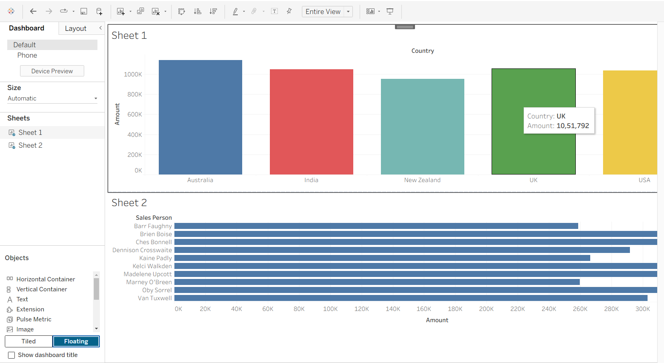

3). Add Business Summary:

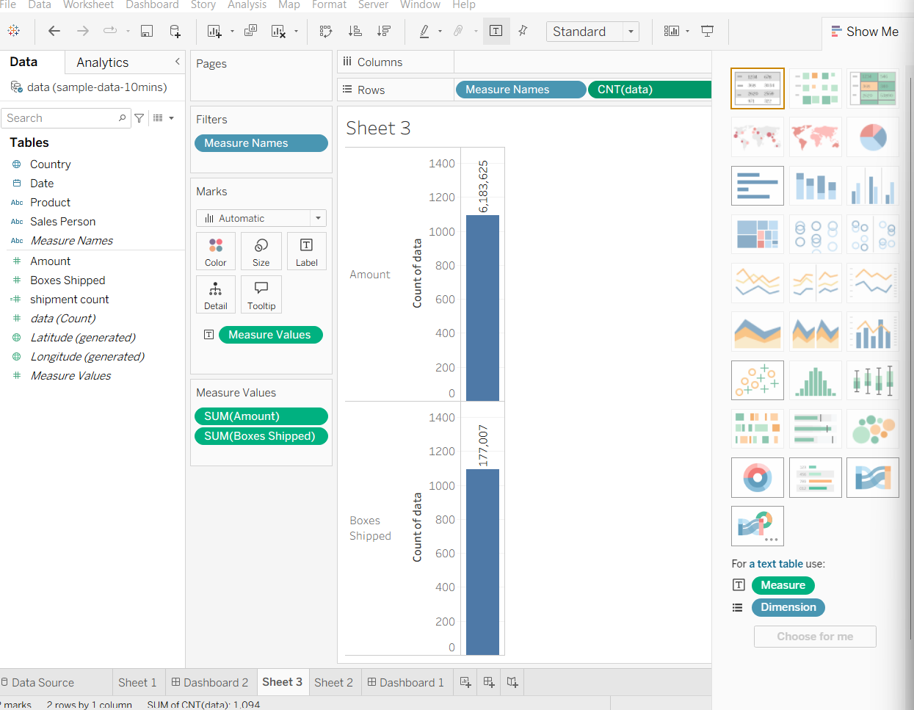

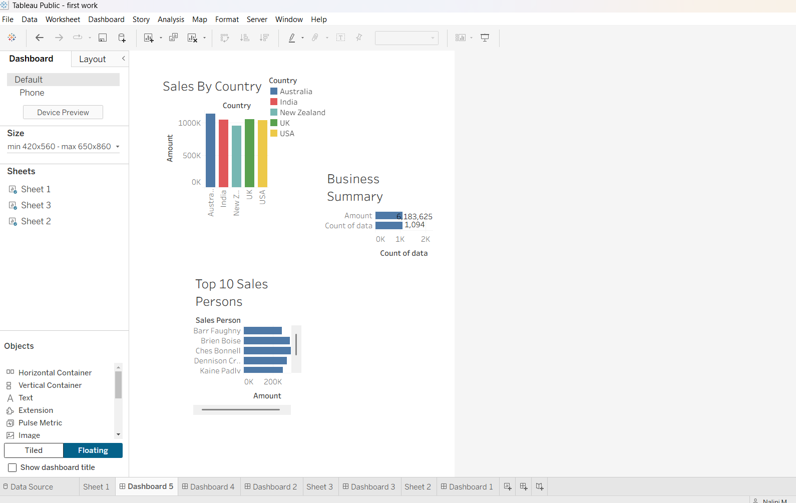

RESULT:

